# Unit 3

**Tools and Technolog**

**y**

**1- Role play**

John was really interested in the things you describe about your daily routine, with that in mind, tell him 5 different tools or technologies that you use on your work.

**Hi John,**

Thank you for your interest in my daily routine! Here are five tools and technologies I frequently use in my work:

1. **Google Meet and Microsoft Teams** – I use these platforms for chats and meetings with colleagues and clients.
2. **Azure Virtual Machines (VMs)** – I access VMs on Azure to manage and run RPAs installed there.
3. **Automation Anywhere** – I make corrections and adjustments to RPA codes using this tool.
4. **Visual Studio Code (VSCode)** – This is my go-to code editor when developing front-end applications with Angular.
5. **Git** – I use Git for version control to collaborate effectively and manage code changes in projects.

18



**3- Did you hear that there will be another Mario Bros’ game?**

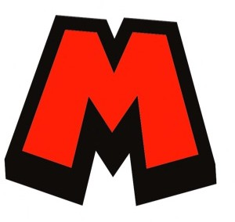**Of course it is not true, but imagine if two Devs from Nintendo are talking about that. Complete the gaps using the verbs in brackets, don’t forget to use the sim**

**ple**

re

**present or present continuous**

**Dev A:** Hey, have you heard about the new Mario Bros game we' working on?

**Dev B:** Yes, I (be) really excited about it! What's the latest progress on the development?

**Dev A:** Well, currently, we (implement) new levels and

(add) interactive elements to enhance the gameplay experience.

**Dev B:** That sounds great! the company (incorporate) any new features or power-ups for Mario?

**Dev A:** Absolutely! We (introduce) a new power-up called the Super Mushroom Boost, which (give) Mario an extra jump height and increased speed.

**Dev B:** That's awesome! I think players (go) to love that.

we also (work) on improving the graphics and animations?

**Dev A:** Definitely! Our team (be) dedicated to creating stunning visuals and smooth animations to bring the game to life. I (use) the latest rendering techniques to achieve that.

**Dev B:** Fantastic! What about the multiplayer mode? our team

(implement) it?

**Dev A:** Yes, we are! We (design) an exciting multiplayer mode where players (can) team up and

(compete) against each other or (join) forces to overcome challenges together.

**Dev B:** That's going to be a hit! How about the music and sound effects?

anyone (create) original compositions?

**Dev A:** Absolutely! We (have) a talented sound design team working on creating catchy tunes and immersive sound effects that will enhance the gaming experience.

**Dev B:** I can't wait for the game's release! It (sound) like it

(go) to be a phenomenal addition to the Mario Bros franchise.

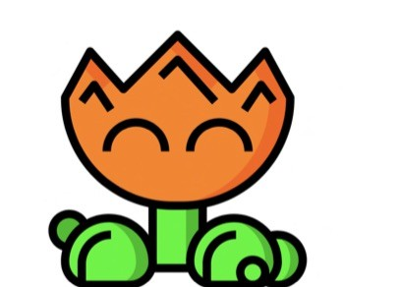**Dev A:** I agree! With our dedicated team and innovative ideas, this game will definitely delight Mario fans worldwide.



22

4- Now that we know what Nintendo is planning for the next Mario Bros’ game, tell us something different or interesting about the work you are developing. Don’t forget to talk about the tools you are using.

Homework

For the next class, create a small essay, just 3 to 5 lines, about your work project planning and tas ks that you have.

23

